George Smith

Lab 10

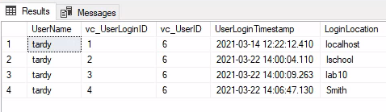

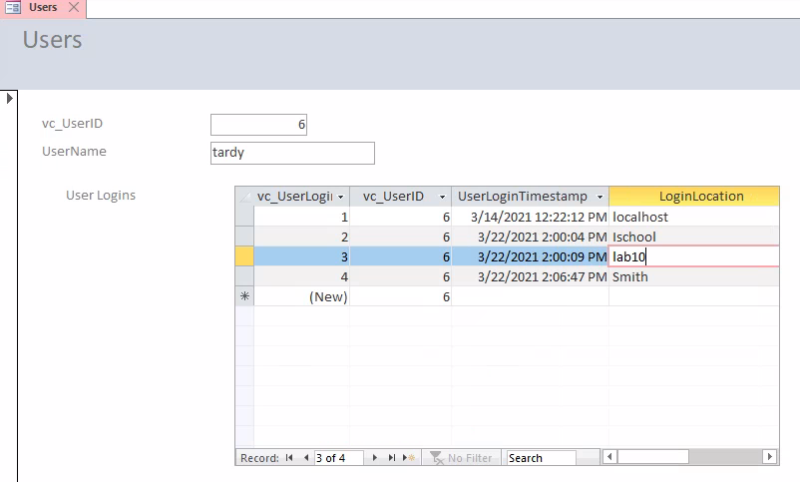

1. The software created an ID for vc_UserLogin ID and created a timestamp based on when I created the login location records.
2. I selected the vc_User ID that was associated with the tardy username
3. A pro of using the SQL server data is it provides an easy to use interface to visualize our database. A con is it would be easy to make mistakes in this interface view, whereas when you are using SQL a mistake would prompt an error.

Part 2

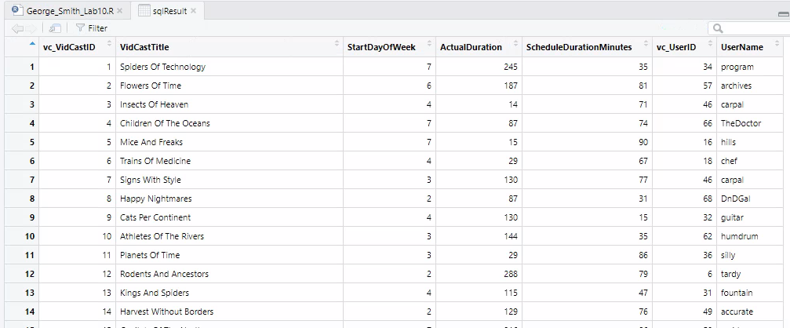

1. The SQL code on line 13 is a select statement that is creating out table shown in SQLResult
2. One way to simplify lines 14 through 23 is to create a view to easily call this table setup.